2025-2026 FORESTRY CHALLENGE CHAMPIONSHIP

FOCUS TOPIC QUESTION

Introduction:
The focus topic is From Research to Application – Perpetuating Variable Density Forest Structure. Students will understand the role of research in influencing land managers’ decisions when designing projects, explain one example of that application in the SERAL project, and outline a plan to perpetuate complex stand structure in SERAL for recently created variable density stands.

Location:
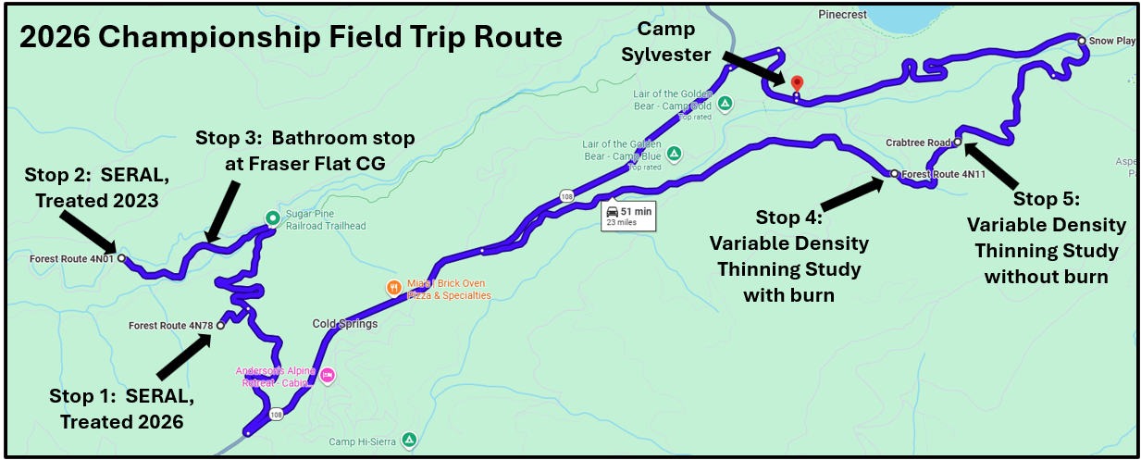
We will visit four field locations on Thursday, April 23 in the current SERAL project and the Stanislaus Experimental Forest (STEF). Stops 1 and 2 are recently created variable density units and stops 4 and 5 were treatments done 15 years ago as part of a research study on variable density.

Background Information:
Historic Forest Conditions – Variable Density (“Clumpy Gappy”)
In 2007, forest researcher Malcolm North and 4 other researchers published a landmark paper, General Technical Report 220 (GTR 220) called “An Ecosystem Management Strategy for Sierran Mixed-Conifer Forests”, which focused on ecological restoration across the landscape. GTR 220 states “In the Sierra Nevada, historical data, narratives (by John Muir in 1911), and reconstruction studies indicate mixed conifer forests were highly clustered with groups of trees separated by sparsely treed or open gap conditions. This clustering can be important for regenerating shade-intolerant pine, increasing plant diversity and shrub cover, moderating surface and canopy microclimate conditions within the tree cluster, and providing a variety of microhabitat conditions for birds and small mammals. In the section titled “Importance of Heterogeneity”, the report states “All of the Sierran reconstruction studies suggest mixed-conifer forests, under an active fire regime, had a naturally clumped distribution containing a variety of size and age classes.” This complex forest structure is sometimes called “clumpy gappy”. Figures 6 and 10 in this report illustrate how treatments could help create this complex forest structure.
Duncan Dunning’s Early Research at the Stanislaus-Tuolumne Experimental Forest
Early in the history of US Forest Service research program, studies of outcomes from different harvest methods were set up on various national forests, including the Stanislaus National Forest (SNF). One study, led by Duncan Dunning on the SNF, had 4 plots within what is now the Stanislaus-Tuolumne Experimental Forest (STEF). In his 1929 Methods of Cutting study, and similar to other studies at the time, trees were mapped in the plots before the experiments began. This mapping of old-growth stands provides a valuable snapshot of the Sierran mixed conifer forest before more substantial European influence. The historical old growth forest consisted of groups of trees, individual large trees, and small gaps. This structure made crown fire uncommon and contributed to the resilience of the forest to wildfire and drought. In 1929, pines (Sugar, Ponderosa, and Jeffrey) comprised 37% of the basal area at this site, with White Fir and Incense Cedar the remainder. Taller understory shrubs (most common within gaps in the tree canopy) covered over a quarter of the forest floor. By the time the plots were remeasured nearly 80 years later, tree density had increased 2.4-fold, gaps had filled with ingrowth trees, and taller shrubs had mostly disappeared. Tree species composition also shifted towards White Fir and Incense Cedar, with pines now comprising only 21% of the basal area. A study of past fires recorded in the tree rings showed that the forest in the study area once burned about every six years prior to 1889, when fire stopped.

Variable Density Thinning Study
Starting in 2009, Eric Knapp, a researcher with the Pacific Southwest Research Station, partnering with the Stanislaus National Forest, set out to test some new approaches to restoring more resilient forest conditions. Among the objectives of the "Variable Density Thinning" study were to:
- Investigate whether a thinning prescription modeled after historical stand structures and designed to generate a high degree of structural variability would benefit a broader array of associated plant and animal species than a more standard even crown spacing treatment.
- Determine how overstory heterogeneity influences tree regeneration and maintains understory heterogeneity over time.
- Evaluate whether leaving some trees in groups would sacrifice tree health and growth.
- Learn the degree to which heterogeneity can be generated with prescribed fire alone as well as the importance of fire in combination with thinning for promoting desirable ecological outcomes.
Three thinning treatments (high variability "HighV" thin, low variability "LowV" thin, and unthinned control, all with or without prescribed fire were randomly assigned to units approximately 10 acres in size. The goal of the HighV thinning prescription was to produce a spatial structure, density, species composition, and size distribution consistent with the historical patterns once observed on this site. Because the study was experimental and was conducted within the Stanislaus Tuolumne Experimental Forest, the 30” diameter cutting limit, which applies to surrounding National Forest System lands, was not used. The researchers purposefully did not include diameter limits in the prescription because diameter limits might have restricted opportunities for generating structural complexity. Because of the current lack of pine compared with historical conditions, leave tree priority among conifers for both thinning treatments was sugar pine > ponderosa/Jeffrey pine > incense cedar > white fir. Thinning was conducted between July and September 2011 and the designated burn units were treated with prescribed fire Nov. 11-18, 2013. No additional treatments have been conducted since, giving us a look at conditions 15 years after harvest and 13 years after prescribed fire.
Results – highlights:
- Both types of thinning reduced stand densities to levels closer to historical values and moved species composition towards pine. Prescribed fire alone was less effective at reducing stand density or altering species composition.
- Thinning treatments suffered far less tree mortality during and after the 2012-2015 drought than the unthinned controls.
- Tree mortality during and after the drought was greater in units treated with prescribed fire, especially if the prescribed fire was not preceded by thinning. Trees in prescribed fire only treatment were not only stressed by fire injury, but also by excess tree density, making them especially vulnerable to bark beetles.
- Many understory plant species are responding most favorably to the combination of either type of thinning plus prescribed fire.
- While the HighV thinning treatment produced a more variable forest structure, the benefits, as measured by factors such as tree survival, growth, regeneration, and habitat creation, are relatively modest at this point. More pronounced benefits may be longer term or may become apparent after additional cycles of prescribed burning are completed in the future.
The vegetation was measured in 2009 before any treatment, in 2012 after thinning, in 2014 after prescribed fire, and at two-to-four-year intervals since. The last measurement was made in 2024. The 2024 data are unpublished.
SERAL and the Application of the Research
In 2020, the Forest Service began planning a new project, called Social and Economic Resilience Across the Landscape, or SERAL. The SERAL project was developed through a collective, collaborative effort of numerous community members, collaborative partners, research experts, and Forest Service employees. One of the main goals of SERAL is to increase forest heterogeneity within and between stands using variable density thinning. In the forested areas of the SERAL project footprint, and in areas without spotted owl protected habitat, the following process was used to prepare the units for treatment:
- Decide on the location and size of the openings and plot ¼ acre centers in single, double, or groups of 4 to create ¼, ½, or 1-acre openings, with equal acreage devoted to each size opening. Openings are being created on 5 to 10% of the total variable density unit acreages.
- Create a 25’ radius buffer around California Black Oaks greater than 12” DBH and pines greater than 24” in DBH, removing all vegetation within the dripline of the identified trees.
- Individually select trees less than 30” DBH in the non-opening areas (called the “matrix”) to reduce stand to target basal areas based on GTR 220 variations for ridgetops, mid slopes, and drainages. These basal area targets are 60 to 80 square feet per acre for ridgetops, 80 to 120 square feet per acre for mid slopes, and 120 to 140 square feet per acre for low areas, swales, and drainages. Favor retaining pines over fir and cedar.
- Although designated clumps of trees are not being retained on purpose, the low areas mentioned in #3 have inherently high basal areas and serve as dense pockets to complete the clumpy gappy complex forest structure.
Work began in 2023 and continues today. Loggers were informed of the prescription and select which trees to harvest based on Designation by Prescription, which eliminates the need to mark trees to be removed. Sawlogs are sent to the SPI mill in Sonora, and the biomass is chipped and trucked to a biomass plant or, where there is a low volume of material, masticated and left onsite.
Perpetuating Variable Density
The work being done to set up variable density units is intended to increase the complexity of forest structure in the SERAL project area and therefore increase forest heterogeneity. However, if treatments are not perpetuated, these areas will likely return to dense stands with almost no openings, as the 1929 Methods of Cutting study plots showed happens over time in the absence of disturbances such as lower-intensity fire. Maintaining openings and clumps in their same positions might be successful over the short term but will not perpetuate complex forest structure once the larger trees age and die.
Resources:
On Wednesday evening, you will be given resources on a flash drive to load onto your team’s computer. Additionally, you can use photos you take during the field trip and statements from foresters you work with and interview during Ask a Forester.
Items to be Addressed in Your Presentation:
- Historic forest conditions in the Sierra Nevada mixed conifer forests with emphasis on heterogenous forest structure
- The value of early research projects recording pre-European forest conditions
- An overview of the Variable Density Thinning Study conducted in the STEF and its results
- How those results are being applied to the SERAL project
- A plan to perpetuate complex forest structure on the SERAL units with metrics to monitor and actions to implement based on those metrics
Final Product:
Your goal is to give a 20-minute presentation using PowerPoint that outlines a plan to perpetuate complex stand structure in the SERAL project’s variable density stands. You are encouraged to use photos and information collected on the fieldtrip, interviews with resource professionals during the Challenge, and the information in the resources provided. Additionally, use the judges’ score sheet as a checklist, to make sure you cover the items on which you will be scored.

